Polyphemus: Project Book; Biel School of Engineering and Architecture
Prev | Appendix A. Technical report | Next

Multimedia over the Internet

Introduction
The core Internet protocols like TCP/IP and UDP/IP do not provide any real-time functionality, therefore they are not able to fulfill the requirements we need for transmitting multimedia data. But the Integrated Services working group in the IETF (Internet Engineering Task Force) developed an enhanced Internet service model called Integrated Services that includes best-effort service and real-time service. The real-time service will enable IP networks to provide quality of service to multimedia applications. Resource ReServation Protocol (RSVP), together with Real-time Transport Protocol (RTP), Real-Time Control Protocol (RTCP), Real-Time Streaming Protocol (RTSP), provides a working foundation for real-time services. Integrated Services allows applications to configure and manage a single infrastructure for multimedia applications and traditional applications. It is a comprehensive approach to provide applications with the type of service they need and in the quality they choose.
Figure A-4. Network Stack
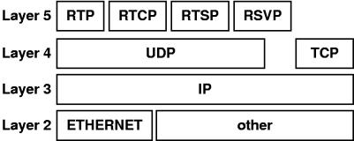
As we can see in this figure, the Integrated Services all use the User Datagram Protocol (UDP) as transport protocol or rely directly on the Internet Protocol (IP).

TCP vs. UDP
We have already seen in the introduction that the solution is the RTP protocol layered on the UDP protocol. But let us consider a few thoughts about using the existing and well known protocols TCP or UDP.

Multimedia over TCP?
TCP is a connection oriented protocol that is reliable including flow control and supports byte-stream in full duplex mode.
Consider that in multimedia applications often multicast methods are used, to serve a couple of clients at the same time. So the connection oriented ability of TCP is not very helpful, allows it only a point to point connection on application level between a server and one client. The multicast method to send data to more than one client is not supported by the TCP protocol.
At the first thought a reliable connection seems a good thing for multimedia. Reliable means, that no single packet will be lost. Expressed in an algorithm it says that the client has to acknowledge every received packed. The client also has to wait for eventually lost packets. This high quality of service costs wait cycles and brings delays with it. Delays is exactly what we do not want in real-time data transmissions. It goes even further, it does not matter if a packet goes lost. For example in a video transmission, we just drop the lost packet and display the previous packet a second time. For the human eye this little trick does not affect the quality. So reliable transmission on transport layer is not exactly what we need for multimedia transmissions.
The ability of flow control is a good thing. For sound or video data it is highly important to get the frames in the right order. IP does not guarantee a sequence in delivering the packets from the network, so a higher level protocol has to take care of that. TCP does it.
Byte-stream in full duplex mode sounds like exactly what we need for real-time application. But if we look a little closer, for a video broadcast to multiple clients is no full duplex mode needed.
TCP is not a good basis to transport multimedia real-time data over a network, to summarize the usability of TCP. Multimedia demands a constant bit rate even if sometimes a packet gets lost and that is exactly what TCP cannot guarantee.

Multimedia over UDP?
To explain it in one sentence: UDP is a connectionless protocol that tries best effort delivery with no flow-control and included message support.
UDP is not reliable and that is one of the key advantages for real-time transmissions. On top of that or because of that it is a best effort delivery protocol. That is exactly what is needed for multimedia data. The circumstances that UDP is connectionless does not matter, is the need for connection orientation in multimedia not very important. UDP also supports multicast methods. In the manner of broadcasting a video to more than one client this is exactly what is needed. Multicast simple multiplies the data on a network segment to a group of clients. Imagine this situation without a multicast method. It would be necessary to set up sessions with each client and to multiply the data on application level. So it would generate a multiple of streams on a single network segment. But there are not only good things on UDP. This protocol does not support flow-control and thats actually very important for real-time applications. So UDP is just a good base that goes in the right direction but it lacks a couple of key functions. That is where RTP comes along.

RTP

Introduction
The Real-time Transport Protocol (RTP) provides support for the transport of real-time data such as video and audio streams. The services provided by RTP include time reconstruction, loss detection, security and content identification. RTP is designed to work in conjunction with the auxiliary control protocol RTCP to get feedback on quality of data transmission and information about participants in the on-going session.
RTP itself does not provide any mechanism to ensure timely delivery. It needs support from lower layers that actually have control over resources in switches and routers. RTP depends on RSVP to reserve resources and to provide the requested quality of service.
RTP/RTCP provides functionality and control mechanisms necessary for carrying real-time content. But RTP/RTCP itself is not responsible for the higher-level tasks like assembly and synchronization. These have to be done at application level.

RTP Header Format
Let us have a closer look at RTP messages. The first 12 octets are fixed header fields present in every RTP message. Further fields may be used for CSRC (contributing source) identifiers.
Figure A-5. RTP Header
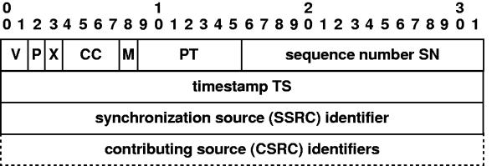
Header description
Version (V): 2 bits
This field identifies the version of RTP. The value for the current version is 2 (the version values "1" and "0" belong to the first draft of RTP).
Padding (P): 1 bit
If the padding bit is set, the packet contains one or more additional padding octets at the end which are not part of the payload. The last octet of the padding is a count of how many padding octets should be ignored. Padding may be needed by some encryption algorithms with fixed block size or for carrying several RTP packets in a lower-layer protocol data unit.
Extension (X): 1 bit
If the extension bit is set, the fixed header is followed by exactly one header extension.
CSRC count (CC): 4 bits
The CSRC (Contributing Source) count contains the number of CSRC identifiers that follow the fixed header.
Marker (M): 1 bit
The interpretation of the marker is defined by an additional profile. It is intended to allow significant events such as frame boundaries to be marked in the packet stream.
Payload type (PT): 7 bits
This field identifies the format of the RTP payload as well as the the encoding/compression schemes. From this payload type identifier, the application knows how to interpret and play out the payload data. Default payload types are defined by RFC 1890. Example specifications include PCM, MPEG, M-JPEG and more. At any given time of transmission, an RTP sender can only send one type of payload, although the payload type may change during transmission, for example, to adjust to network congestion.
Sequence Number (SN): 16 bits
The sequence number increments by one for each RTP data packet sent and may be used by the receiver to detect packet loss and to restore packet sequence. The initial value of the sequence number is randomly set to make known plaintext attacks on encryption more difficult, even if the source itself does not encrypt.
Timestamp (TS): 32 bits
The timestamp reflects the sampling instant of the first octet in the RTP data packet. The sampling instant must be derived from a clock that increments monotonically and linearly in time, to allow synchronization and jitter calculations. The clock frequency is dependent on the format of data carried as payload. The initial value is randomly set. Several consecutive RTP packets may have equal timestamps if they are generated at once, e.g. belong to the same video frame. However, RTP itself is not responsible for the synchronization. This has to be done in the application level.
Sync. SSRC: 32 bits
The SSRC (Synchronization Source) field identifies the synchronization source (stream). This identifier is chosen randomly, with the intent that no two synchronization sources within the same RTP session will have the same SSRC identifier. If a source changes its source transport address, it must also choose a new SSRC identifier to avoid being interpreted as a looped source.
CSRC list: 0 - 15 items, 32 bits each.
Contributing sources for the payload contained in this packet. The number of identifiers is given by the CC field.

RTCP - Real-Time Control Protocol

Introduction
We have already mentioned that RTCP extends the RTP with a control functionality. In an RTP session, participants periodically send RTCP packets to convey feedback on quality of data delivery and information of membership.
Five different packets have been defined for carrying control information.
SR
Sender report, for transmission and reception statistics from session participants that are active senders.
RR
Receiver report, for reception statistics from session participants, that are not active senders.
SDES
Source description items, including CNAME
BYE
Indicates end of participation
APP
Application specific functions
Through these control information packets, RTCP provides the following functions:
The primary function of RTCP is to provide Quality of Service monitoring and congestion control. The control information is useful to the senders, the receivers and third-party monitors. The sender can adjust its transmission based on the receiver report feedback. This is similar to the flow and congestion control in other transport protocols. The receivers can determine whether a congestion is local, regional or global. This feedback function is performed by the RTCP sender and receiver reports described below.
RTCP carries a persistent transport-level identifier for an RTP source called the canonical name or CNAME. Since the SSRC identifier may change if a conflict is discovered or a program is restarted, receivers require the CNAME to keep track of each participant. Receivers also require the CNAME to associate multiple data streams from a given participant in a set of related RTP sessions, for example to synchronize audio and video.
The first two functions require that all participants send RTCP packets, therefore the rate must be controlled in order for RTP to scale up to a large number of participants. By having each participant send its control packets to all the others, each can dependently observe the number of participants. This number is used to calculate the rate at which the packets are sent.
Now, let us have a closer look at the format of the different RTCP packets. Each RTCP packet begins with a fixed header part similar to that of RTP data packets, followed by structured elements that may be of variable length according to the packet type. Each packet ends on a 32-bit boundary. Multiple RTCP packets may be concatenated without any intervening separators to form a compound RTCP packet that is sent in a single packet of the lower layer protocol.

SR - Sender Report
The sender report packet consists of three sections, possibly followed by a fourth profile-specific extension section if defined.
Figure A-6. RTCP SR Header
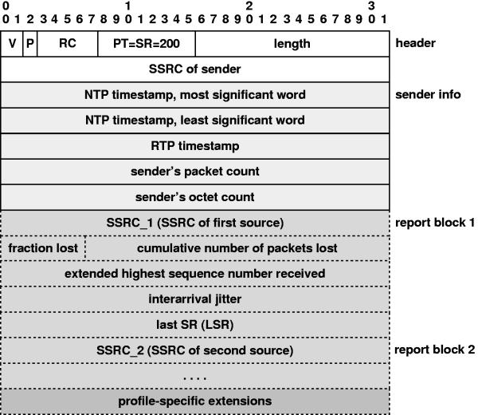
SR - Section one. The first section is 8 octets long
Version (V): 2 bits
Identifies the version of RTP, which is the same in RTCP packets as in RTP data packets. The current version is two (2).
Padding (P): 1 bit
If the padding bit is set, this RTCP packet contains some additional padding octets at the end which are not part of the control information. That last octet of the padding is a count of how many padding octets should be ignored. Some encryption algorithms with fixed block sizes may need padding. In a compound RTCP packet, padding should only be required on the last individual packet because the compound packet is encrypted as a whole.
Reception count: 5 bits
The number of reception report blocks contained in this packet. A value of zero is also valid.
Packet type: 8 bits
Contains the constant 200 to identify this as an RTCP SR packet.
Length: 16 bits
The length is the RTCP packet in 32 bit words minus one, including the header and any padding.
SSRC: 32 bits
The synchronization source identifier for the originator of this SR packet.
SR - Section two. The second section, the sender information, is 20 octets long and is presented in every sender report packet. It summarizes the data transmissions from this sender.
NTP timestamp: 64 bits
Indicates the wall clock time when this report was sent so that it may be used in combination with timestamps returned in reception reports from other receivers to measure round-trip propagation to those receivers. A sender that has no notion of wall clock or elapsed time may set the NTP timestamp to zero.
RTP timestamp: 32 bits
Corresponds to the same time as the NTP timestamp, but in the same units and with the same random offset as the RTP timestamps in the data packets.
Sender PKT count: 32 bits
The total number of RTP data packets by the sender since starting transmission up until the time this SR packet was generated. The count is reset if the sender changes its SSRC identifier.
Sender octet count: 32 bits
The total number of payload octets transmitted in RTP data packets by the sender since starting transmission. The count is reset if the sender changes its SSRC identifier. This field can be used to estimate the average payload data rate.
SR - Section three. The third section contains zero or more reception report blocks depending on the number of other sources heard by this sender since the last report. Each reception report block conveys statistics on the reception of RTP packets from a single synchronization source. Receivers do not carry over statistics when a source changes its SSRC identifier due to a collision.
SSRC_n (src ident): 32 bits
The SSRC identifier of the source to which the information in this reception report block pertains.
Fraction lost: 8 bits
The fraction of RTP data packets from source SSRC_n lost since the previous SR or RR packet was sent, expressed as a fixed point number with the binary point at the left edge of the filed. That is equivalent to taking the integer part after multiplying the loss fraction by 256. This fraction is defined to be the number of packets lost divided by the number of packets expected, as defined in the next paragraph.
Total packets lost: 24 bits
Total number of RTP data packets from the source SSRC_n that have been lost since the beginning of reception. This number is defined to be the number of packets expected less the number of packets actually received, where the number of packets received includes any which are late or duplicates. Thus packets that arrive late are not counted as lost, and the loss may be negative if there are duplicates. The number of packets expected is defined to be the extended last sequence number received, as defined next, less the initial sequence number received.
Last sequence #: 32 bits
The low 16 bits contain the highest sequence number received in an RTP data packet from source SSRC_n, and the most significant 16 bits extend that sequence number with the corresponding count of sequence number cycles. Note that different receivers within the same session will generate different extensions to the sequence number if their start times differ significantly.
Inter arrival jitter: 32 bits
An estimate of the statistical variance of the RTP data packet inter-arrival time, measured in timestamp units and expressed as an unsigned integer. The inter-arrival jitter J is defined to be the mean deviation of the difference D in packet spacing at the receiver compared to the sender for a pair of packets. As shown in the equation below, this is equivalent to the difference in the "relative transit time" for the two packets (i and j). The relative transit time is the difference between a packets RTP timestamp Si and the receiver's clock at the time of arrival, Ri measured in the same units.
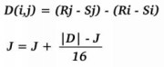

RR - Receiver
Report The format of the receiver report (RR) packet is the same as that of the SR packet except that the packet type field contains the constant 201 and the five words of sender information are omitted (these are the NTP and RTP timestamps and senders packet and octet counts). The remaining fields have the same meaning as for the SR packet.
Figure A-7. RTCP RR Header
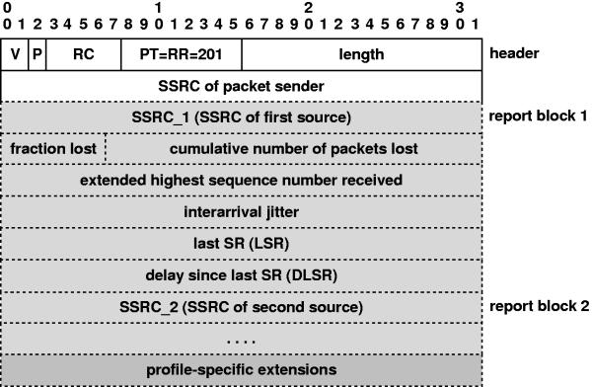
An empty RR packet (RC=0) is put at the head of a compound RTCP packet when there is no data transmission or reception to report.

SDES - Source description
The SDES packet is composed of a header and zero or more chunks, each of which is composed of items describing the source identified in that chunk.
Figure A-8. RTCP SDES Header
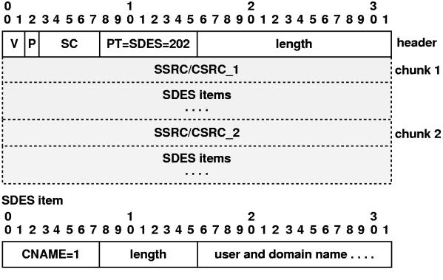
RTCP SDES Header Description
Version (V), SSRC, Padding (P), length:
see SR packet description
Packet type (PT): 8 bits
Contains the constant 202 to identify this as an RTCP SDES packet.
Source Count (SC): 5 bits
The number of SSRC/CSRC chunks contained in this SDES packet. A value of zero is valid but useless.
SDES item: n bits
The source description item has to be unique among all session participants, one good choice is to use the canonical name of the source.

BYE - The Goodbye
The BYE packet indicates that one or more sources are no longer active. The format of the BYE packet is the following:
Figure A-9. RTCP BYE Header
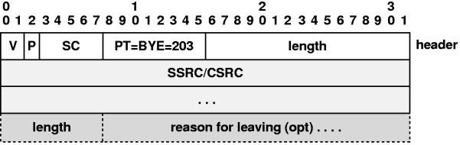
RTCP BYE Header
Version (V), SSRC, Padding (P), length:
see SR packet description.
Packet type (PT): 8 bits
Contains the constant 203 to identify this as an RTCP BYE packet.
Source count (SC): 5 bits
The number of SSRC/CSRC identifiers included in this BYE packet.

Other protocols

RSVP
RSVP is the network control protocol that allows data receiver to request a special end-to-end quality of service for its data flows. Real-time applications use RSVP to reserve necessary resources at routers along the transmission paths so that the requested bandwidth can be available when the transmission actually takes place. RSVP is a main component of the future Integrated Services Internet which can provide both best-effort and real-time service.
RSVP is used to set up reservations for network resources. When an application in a host (the data stream receiver) requests a specific quality of service (QoS) for its data stream, it uses RSVP to deliver its request to routers along the data stream paths. RSVP is responsible for the negotiation of connection parameters with these routers. If the reservation is setup, RSVP is also responsible for maintaining router and host states to provide the requested service.
The reservation requests are initiated by the receivers. They do not need to travel all the way to the source of the sender. Instead, it travels upstream until it meets another reservation request for the same source stream, then merges with that reservation. The figure below shows how the reservation requests merge as they progress up the multicast tree.
Figure A-10. RSVP merge
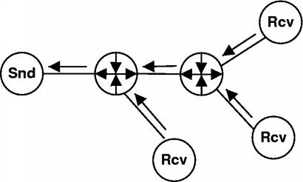
This reservation merging leads to the primary advantage of RSVP: scalability---a large number of users can be added to a multicast group without increasing the data traffic significantly. So RSVP can scale to large multicast groups and the average protocol overhead decreases as the number of participants increases.
The reservation process does not actually transmit the data and provide the requested quality of service. But through reservation, RSVP guarantees the network resources are available when the transmission actually takes place.

RTSP
RTSP, the Real-Time Streaming Protocol, is a client-server multimedia presentation protocol to enable controlled delivery of streamed multimedia data over IP network. It provides "VCR-style" remote control functionality for audio and video streams, like pause, fast forward, reverse, and absolute positioning. Sources of data include both live data feeds and stored clips.
RTSP is an application-level protocol designed to work with lower-level protocols like RTP, RSVP to provide a complete streaming service over Internet. It provides means for choosing delivery channels (such as UDP, multicast UDP and TCP), and delivery mechanisms based upon RTP. It works for large audience multicast as well as single-viewer unicast.
RTSP aims to provide the same services on streamed audio and video just as HTTP does for text and graphics. It is designed intentionally to have similar syntax and operations so that most extension mechanisms to HTTP can be added to RTSP.
In RTSP, each presentation and media stream is identified by an RTSP URL. The overall presentation and the properties of the media are defined in a presentation description file, which may include the encoding, language, RTSP URLs, destination address, port, and other parameters. The presentation description file can be obtained by the client using HTTP, email or other means.
But RTSP differs from HTTP in several aspects. First, while HTTP is a stateless protocol, an RTSP server has to maintain "session states" in order to correlate RTSP requests with a stream. Second, HTTP is basically an asymmetric protocol where the client issues requests and the server responds, but in RTSP both the media server and the client can issue requests. For example the server can issue an request to set playing back parameters of a stream.

Prev | Home | Next
Multimedia over packet oriented networks | Up | Conclusion

Conclusion
The Real Time Protocol suite seems to be complicated. But it is worth it. RTP brings the stream to the TCP/IP suite which was certainly not designed for such kind of application. The suite provides just the information it does not define how the application should act or react on this information. That gives one the freedom of using RTP for all kind of applications based on streams. But there are limitations coming with the TCP/IP v4. RSVP is a approach to get around such limitations but as long as not every router in the Internet does understand the RSVP it simply will not work. So we think QoS might be interesting for Intranet solutions but not for the Internet. For such a service we might have to wait until TCP/IP v6 is established.

References
Cyclop III Diploma Work by A.Brand, M.Trachsel University of Applied Sciences Biel/Bienne (http://www.hta-bi.bfh.ch/Projects/cyclop99)
Telematics_1 Script by H.Keller, Prof. for Telematics University of Applied Sciences Biel/Bienne (http://www.hta-bi.bfh.ch/~klh/)
RFC1889 - RTP a transport protocol for realtime applications
RFC1890 - RTP Profile for Audio and Video
Multimedia over IP technical report by Chunlei Liu CIS Departement University of Ohio (http://www.cis.ohio-state.edu/~jain/cis788-97/ip_multimedia/index.html)

